Etapa 2 Proiect BD

# Tabele

Agentii:

Modele:

Categorii:

Clienti:

Contracte:

Evenimente:

Locatii:  
  
Participari:  
  
Interogari

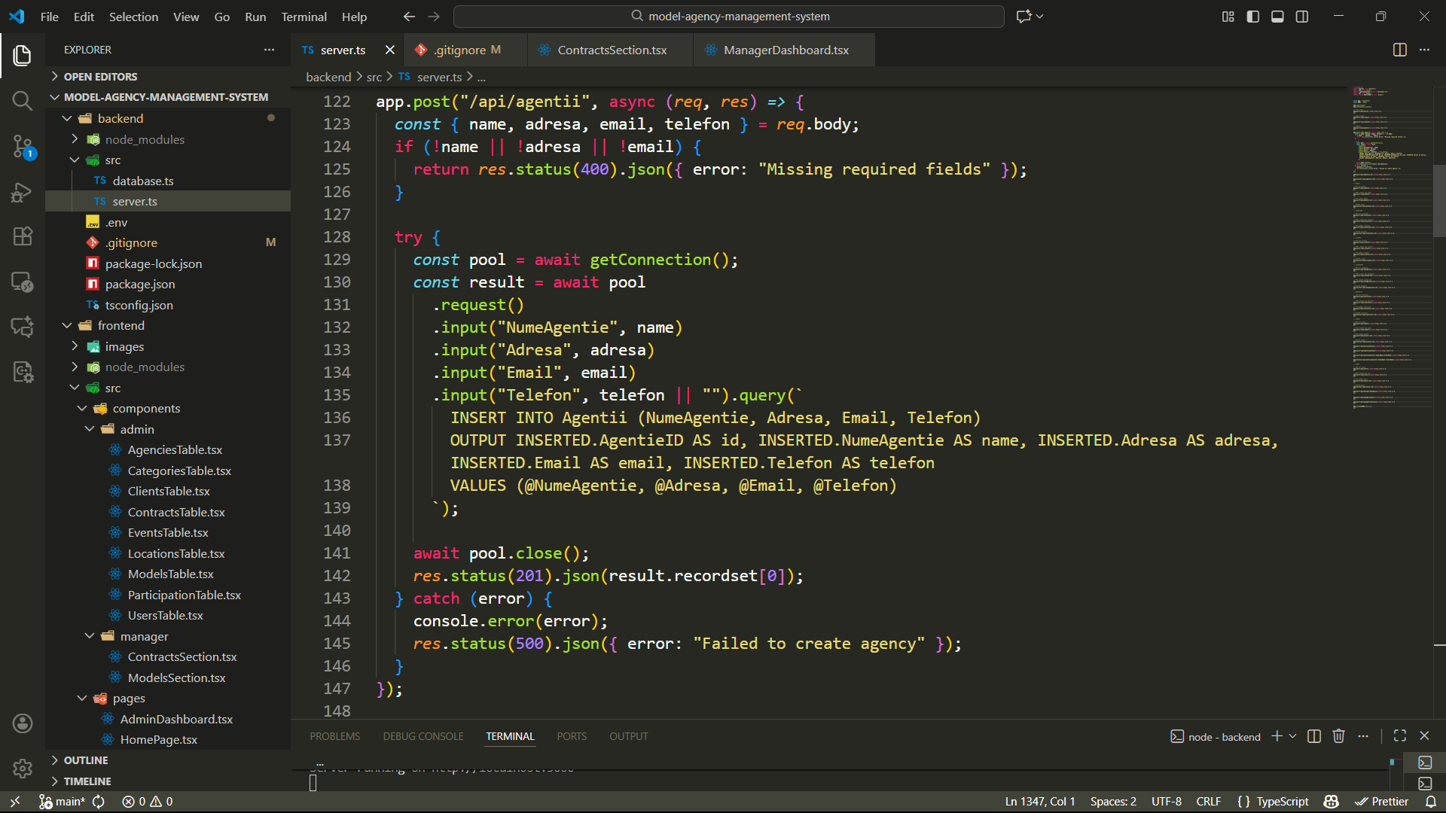

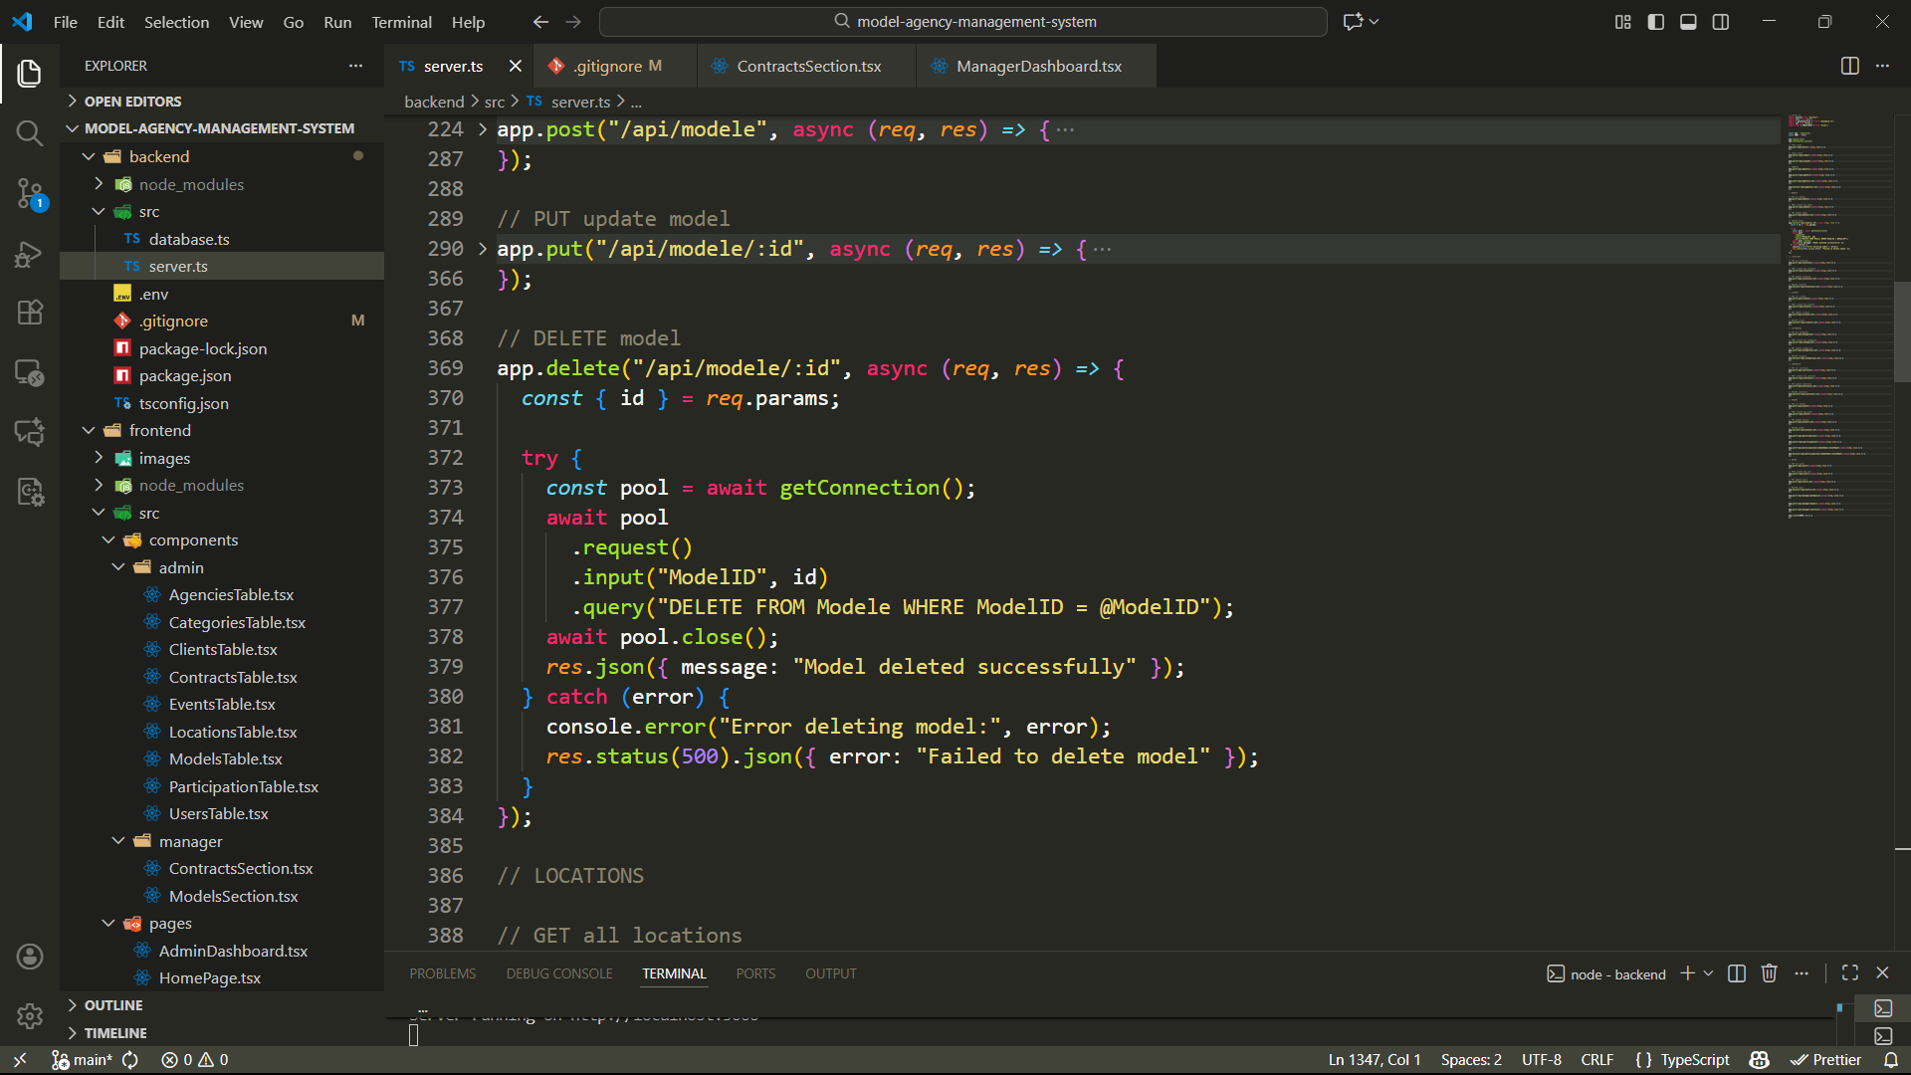

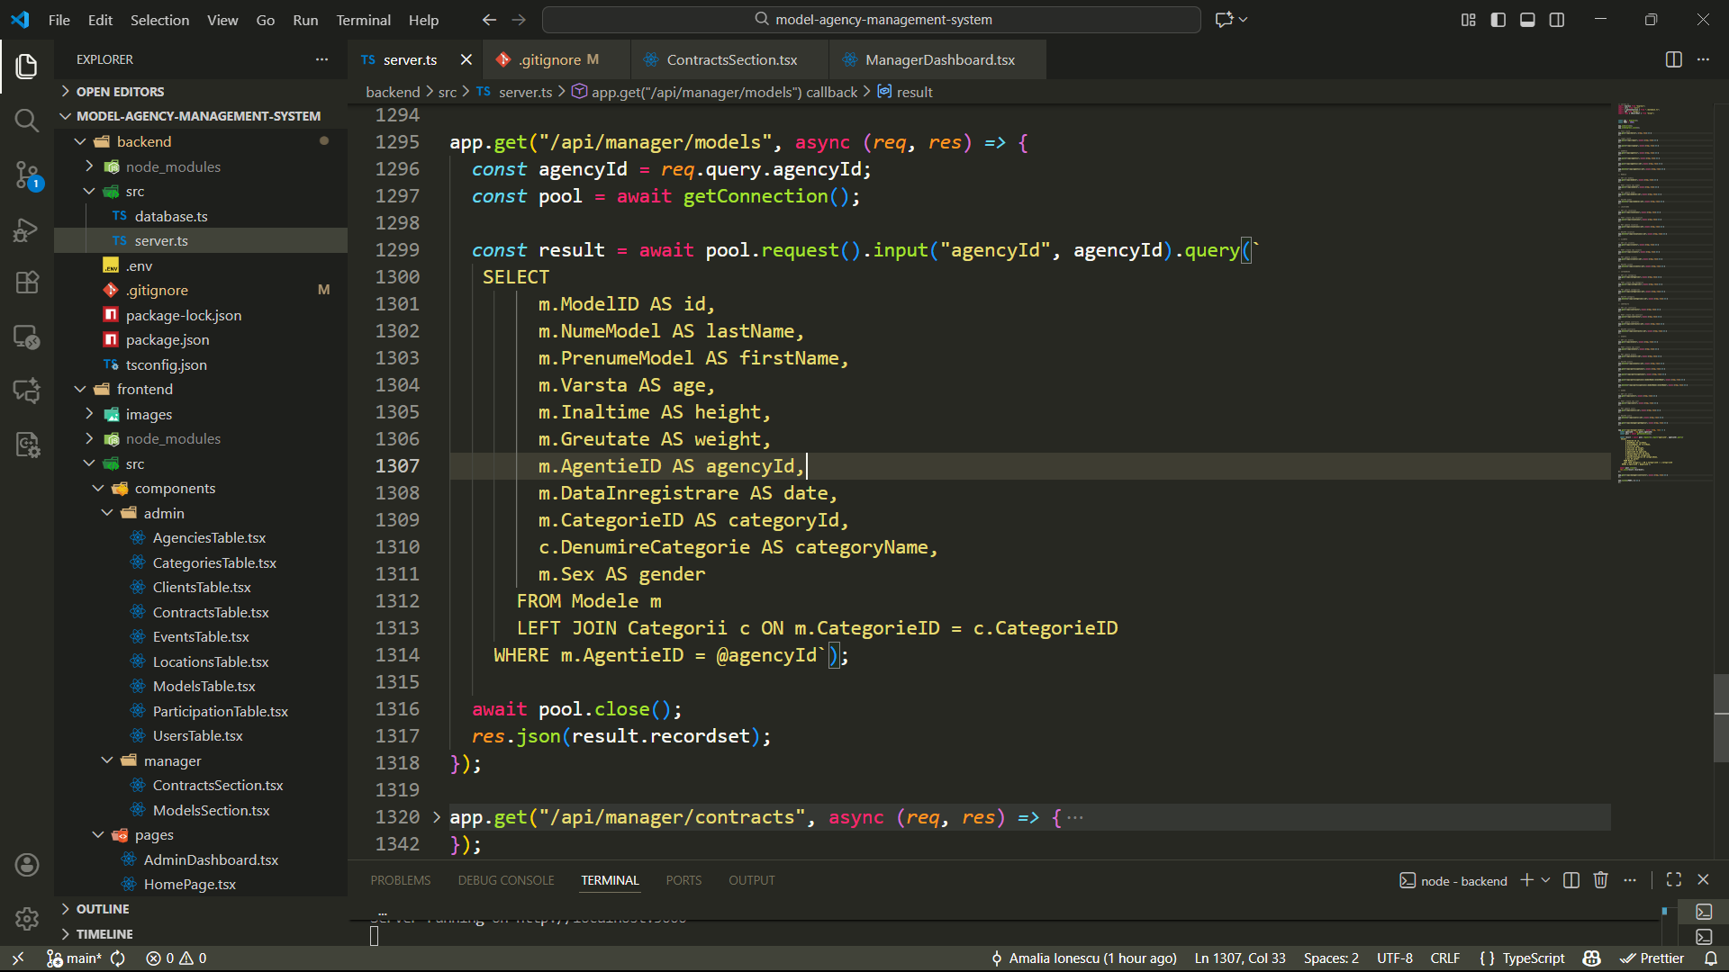

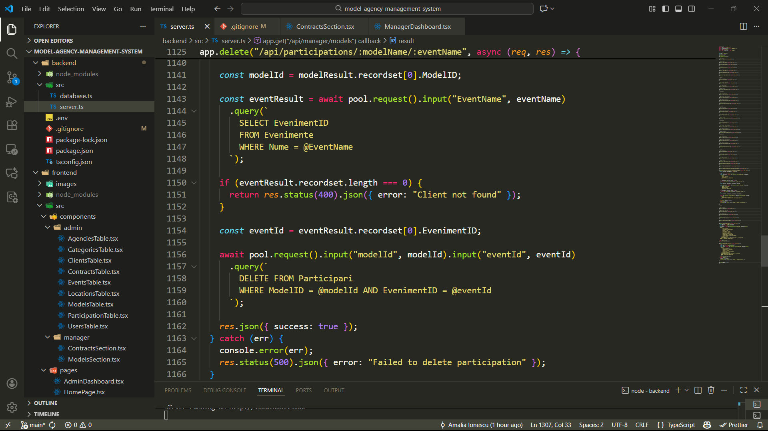

# Pagini

